Task Description:

Launch jenkins and explore creating projects and users.
Solution :
Step 1: Launch an AWS EC2 Instance with the following Requirements
Navigate to EC2 → Instances → Launch Instance.
Configure the instance:
AMI: Amazon Linux 2
Instance Type: t2.micro (Free Tier eligible)
Key Pair: Create or select an existing key pair
Network Settings:
Allow SSH (port 22) from your IP
Allow Custom TCP port 8080 (Jenkins)
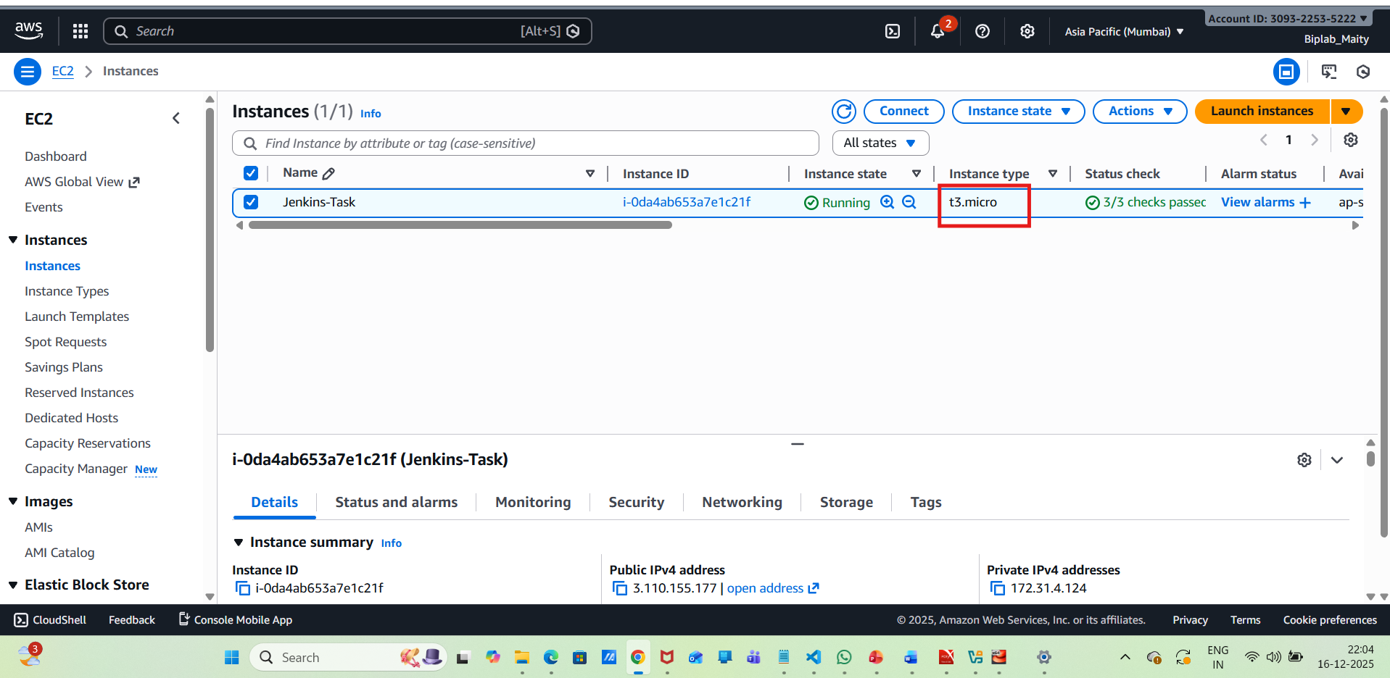
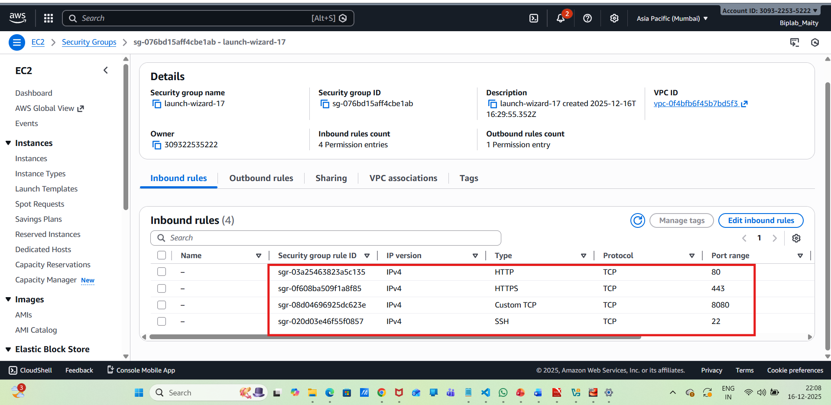
Step 2: Connect to the EC2 Instance
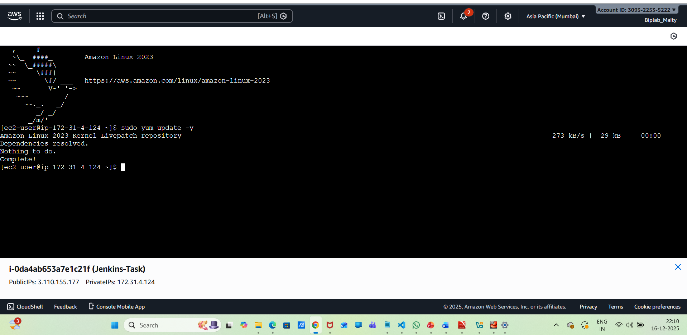
Step 3: Install Java (Prerequisite for Jenkins)
Update the system:
sudo yum update -y
Install Java:
sudo yum install java-17-amazon-corretto -y
Verify installation:
java -version
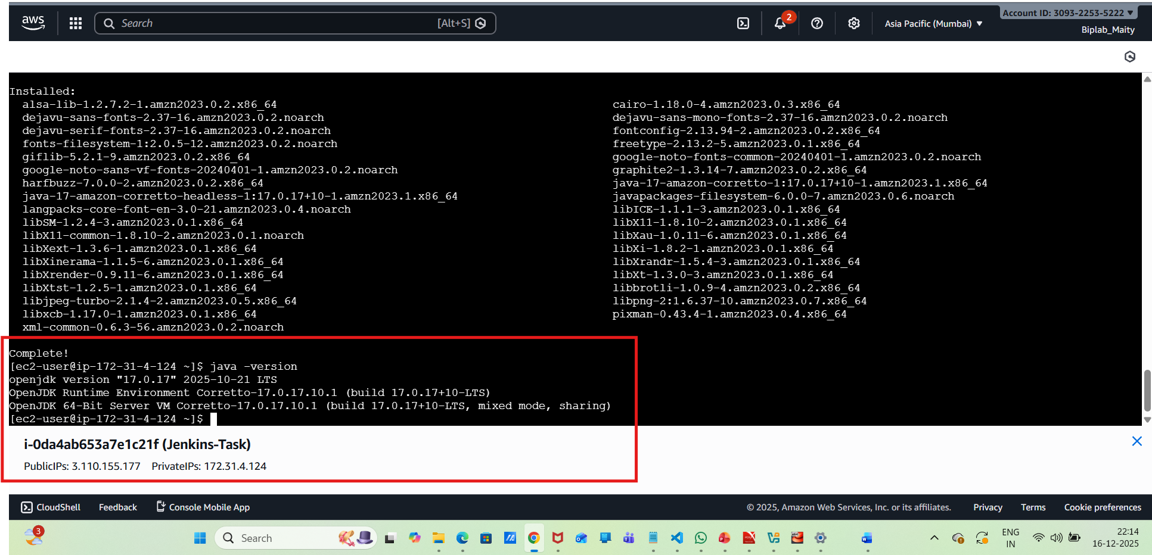
Step 4: Install Jenkins
Add the Jenkins repository:
sudo wget -O /etc/yum.repos.d/jenkins.repo \https://pkg.jenkins.io/redhat-stable/jenkins.repo
Import the Jenkins key:
sudo rpm --import https://pkg.jenkins.io/redhat-stable/jenkins.io-2023.key
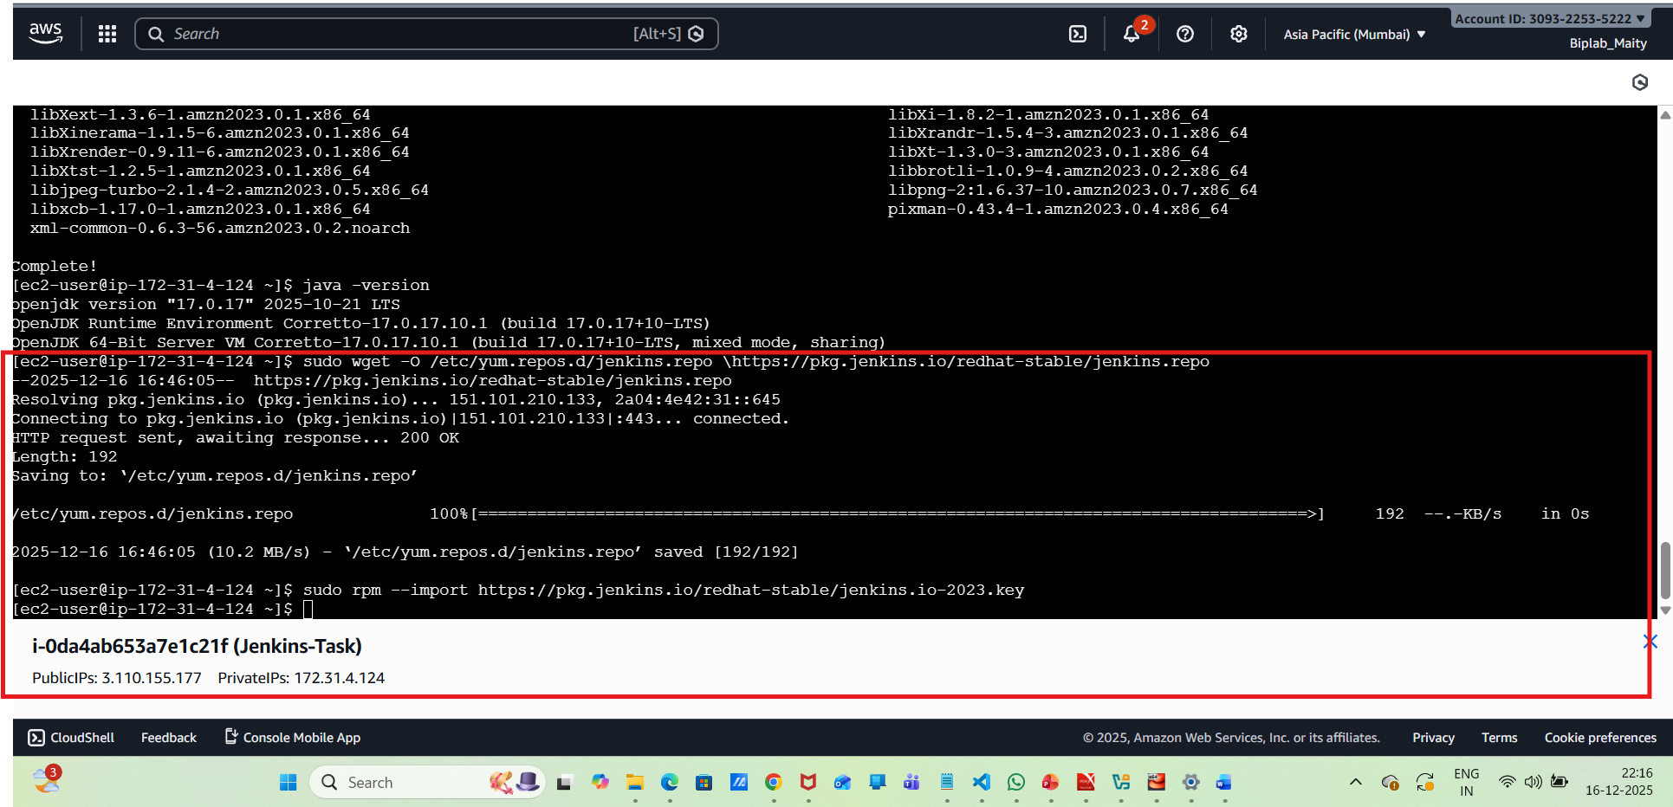
Install Jenkins and verify :
sudo yum install jenkins -y
jenkins --version
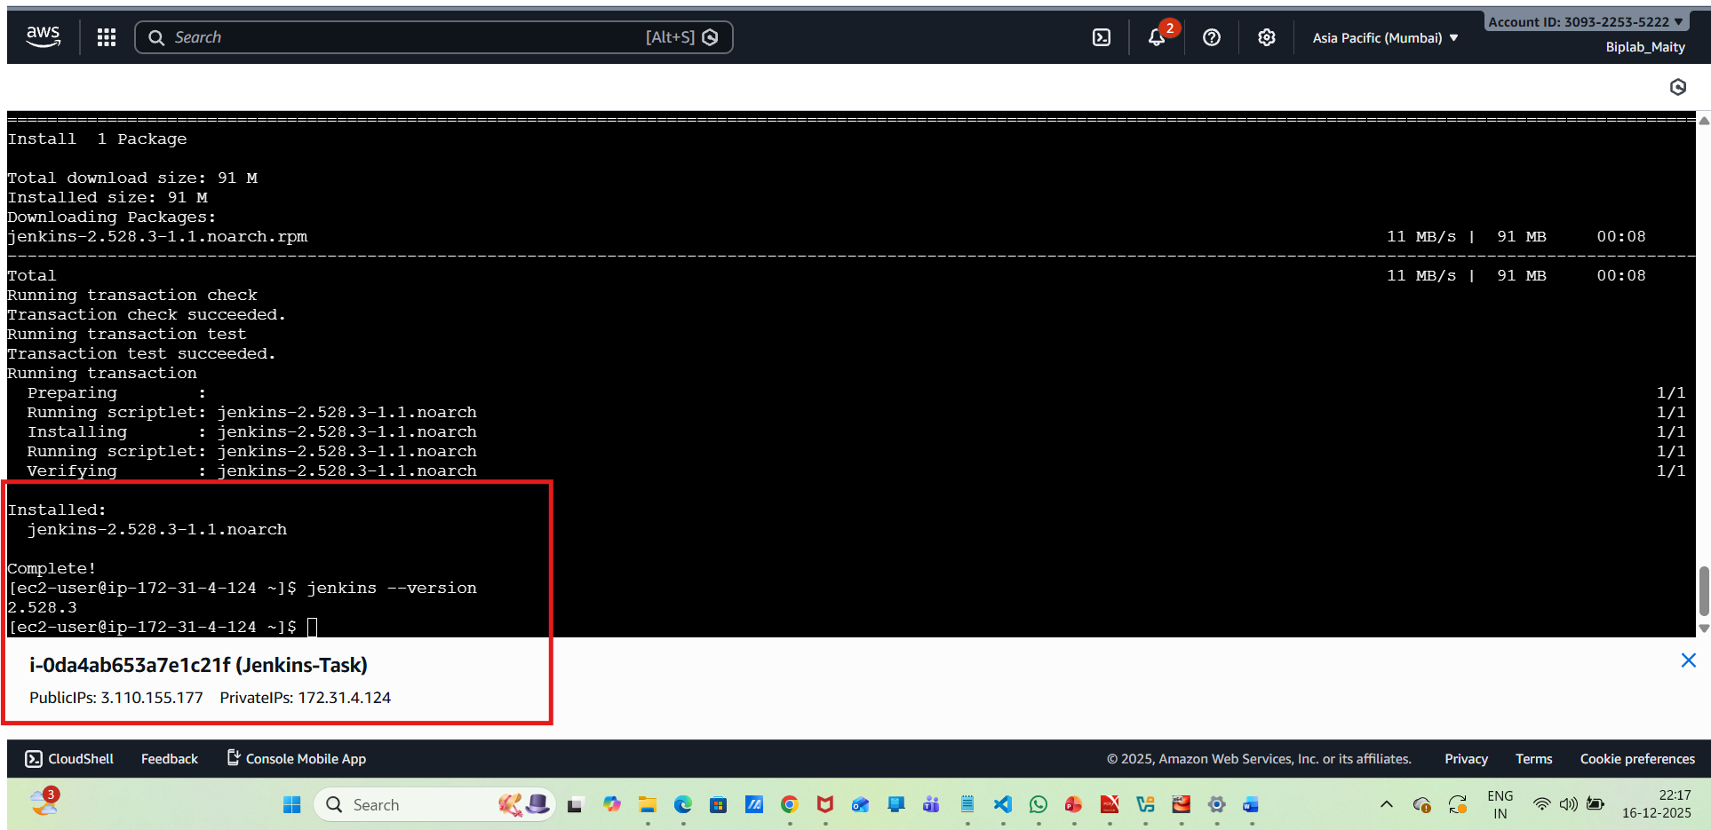
Step 5: Start and Enable Jenkins
Start Jenkins:
sudo systemctl start Jenkins
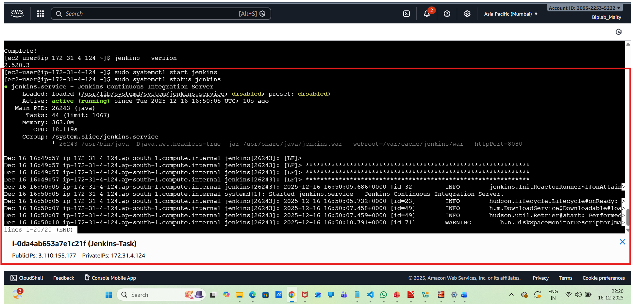
Enable Jenkins :
sudo systemctl enable jenkins
Check Jenkins status:
sudo systemctl status Jenkins
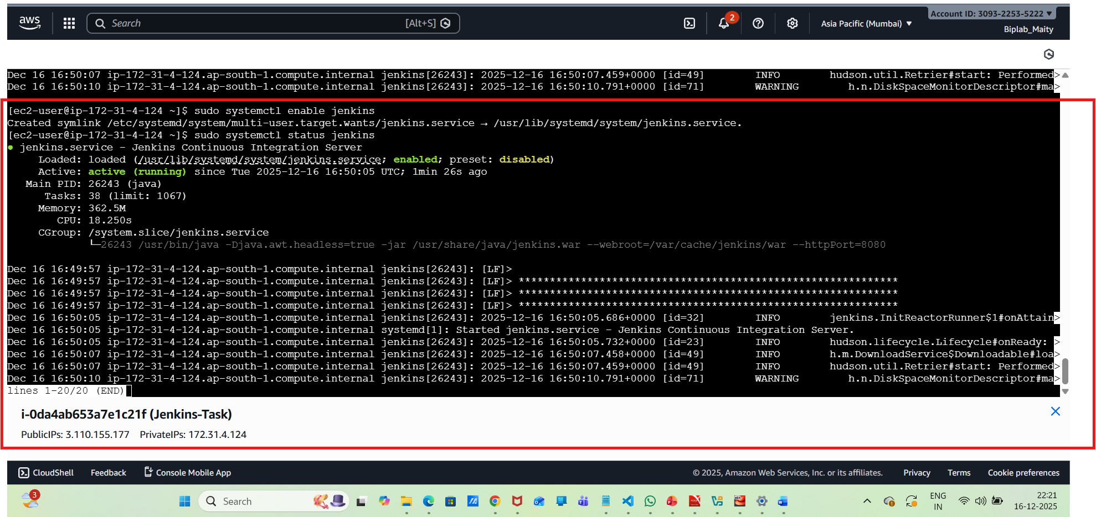
Step 6: Access Jenkins Web Interface
Open a browser and go to:
http://3.110.155.177:8080
Get the initial admin password:
sudo cat /var/lib/jenkins/secrets/initialAdminPassword
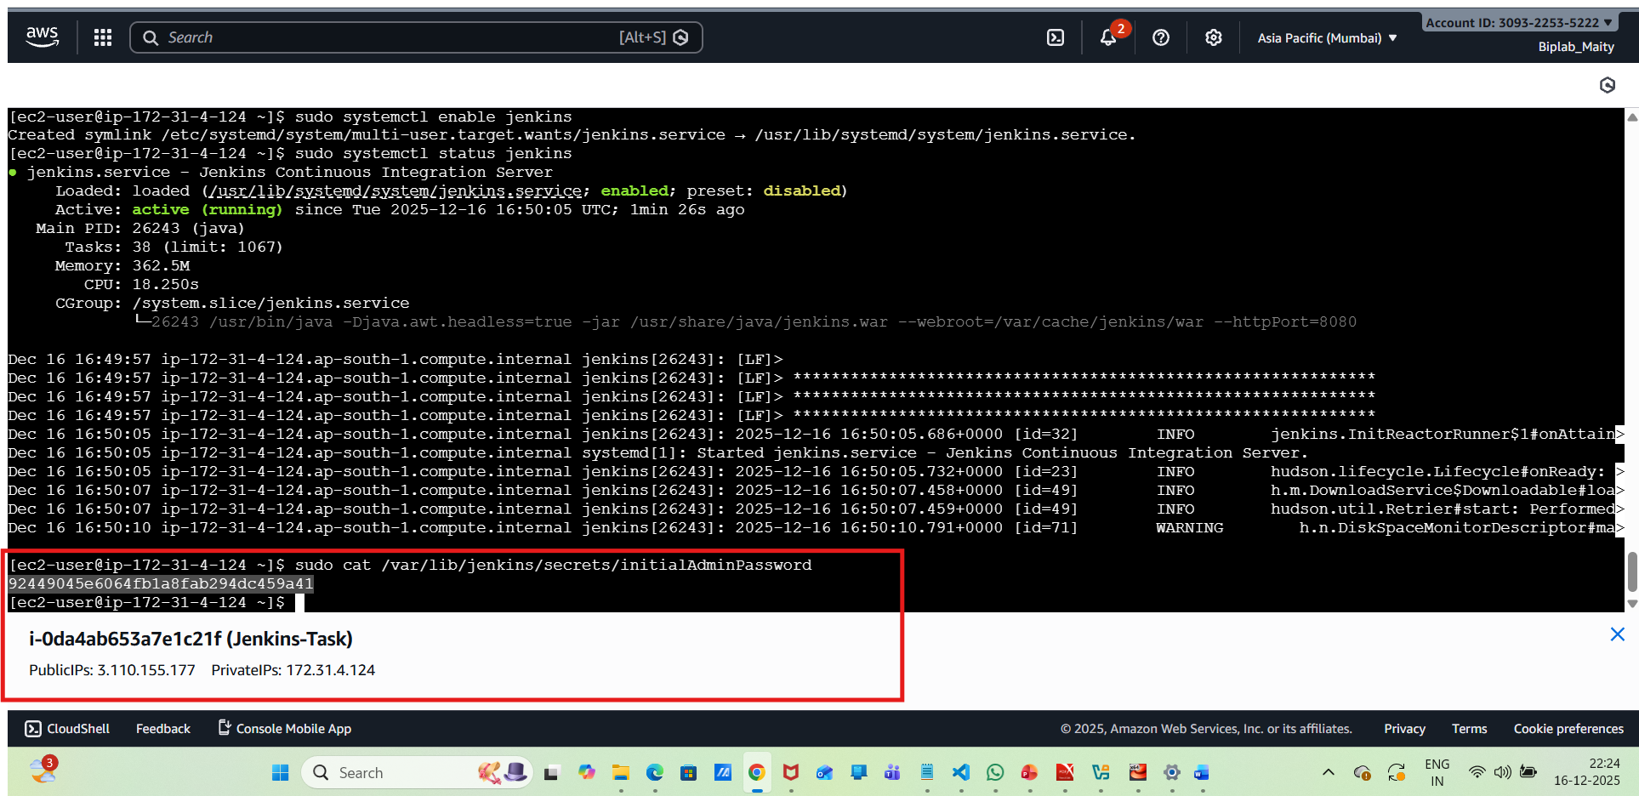
Paste the password into the Jenkins UI.
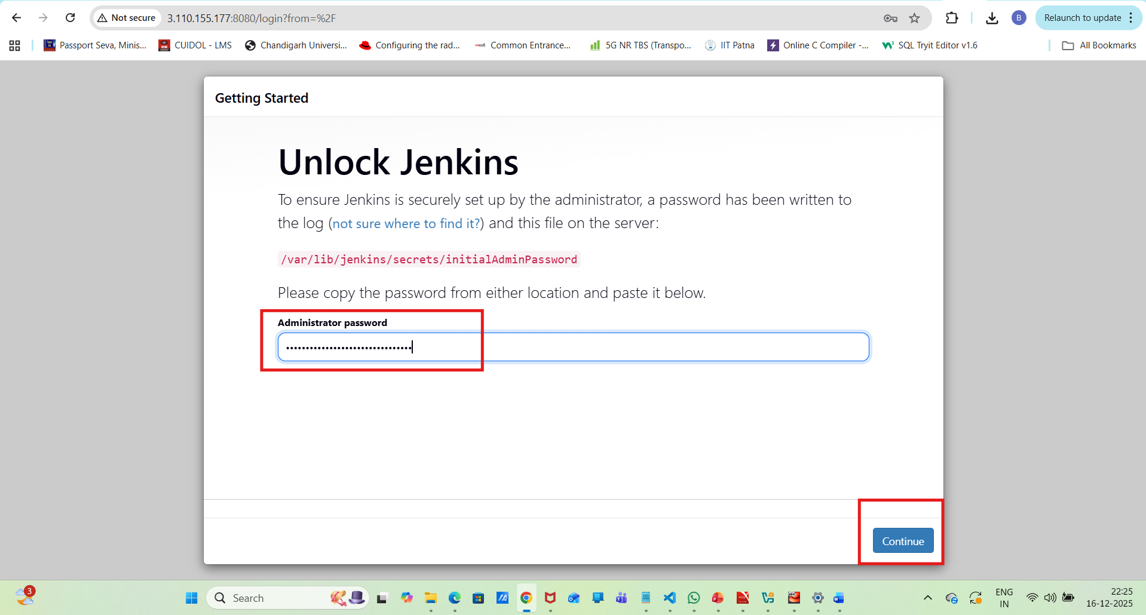
Step 7: Initial Jenkins Setup
Click Install Suggested Plugins.
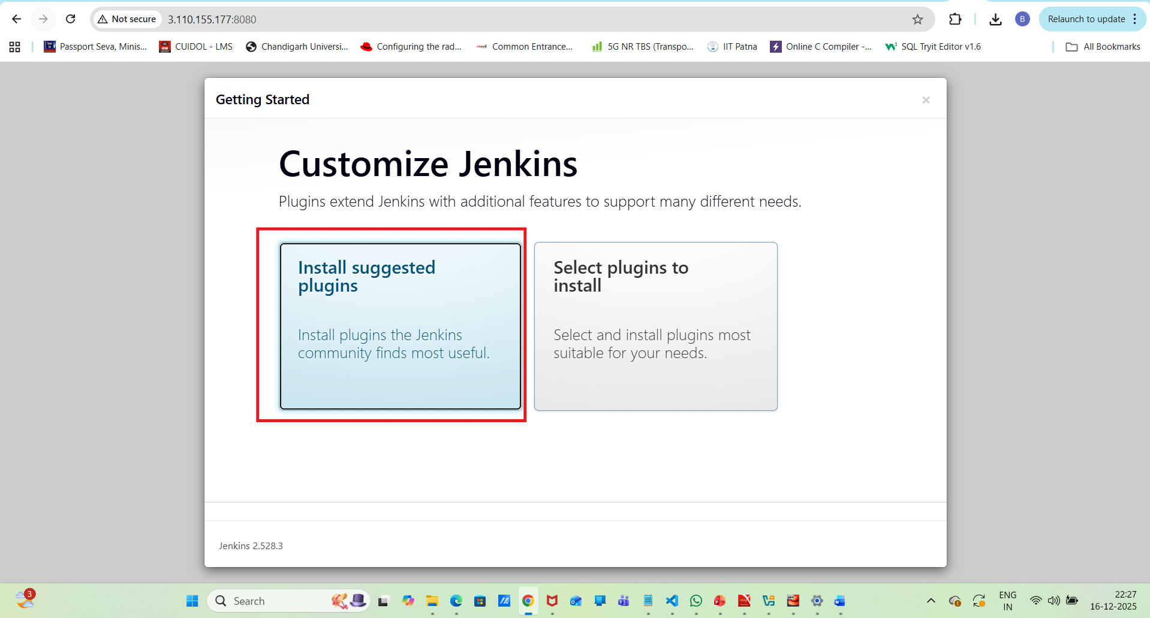
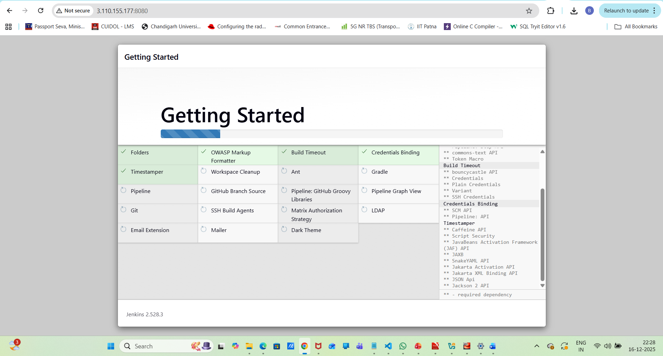
Create the Admin User:
Username-Biplab
Password-biplab123
Confirm Password-biplab123
Full name-Biplab Maity
Email-biplab.bapparaj@gmail.com
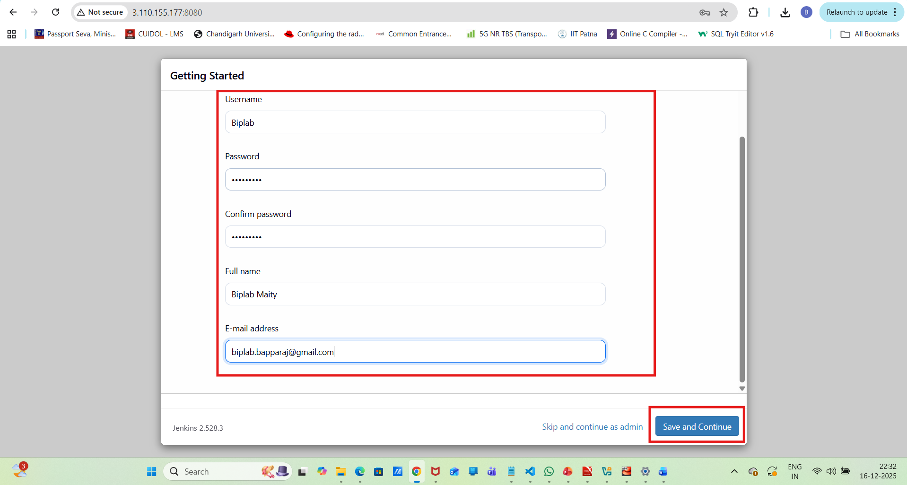
Complete the setup and log in.
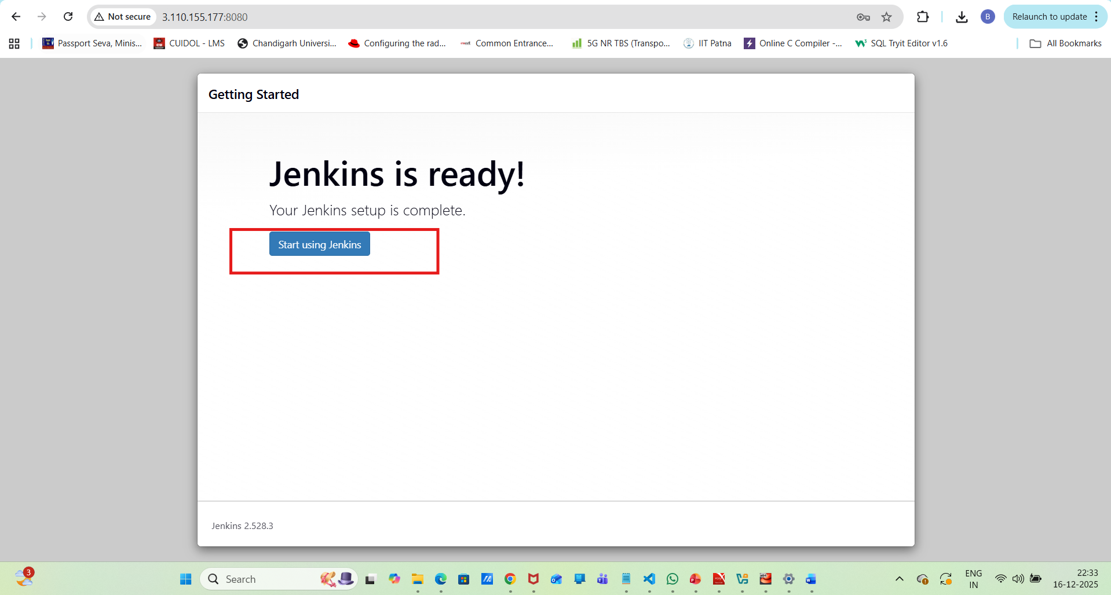
Step 8: Create a Jenkins Project (Job)
On the Jenkins dashboard, click New Item.
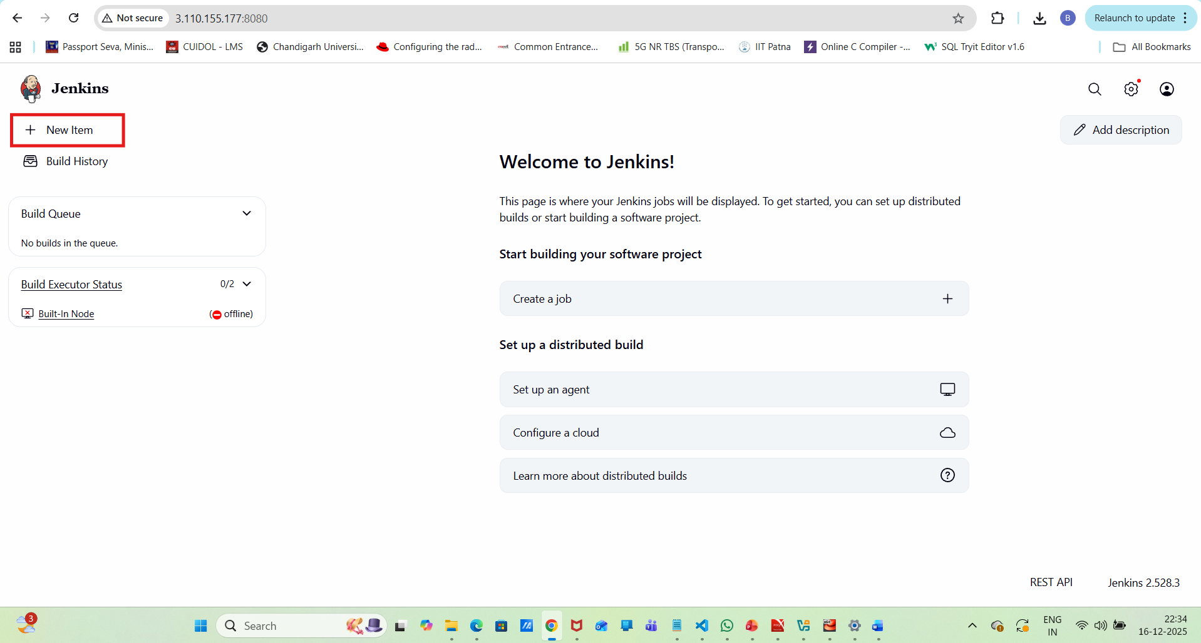
Enter a project name--Jenkins-demo_projects
Select Freestyle Project → Click OK.
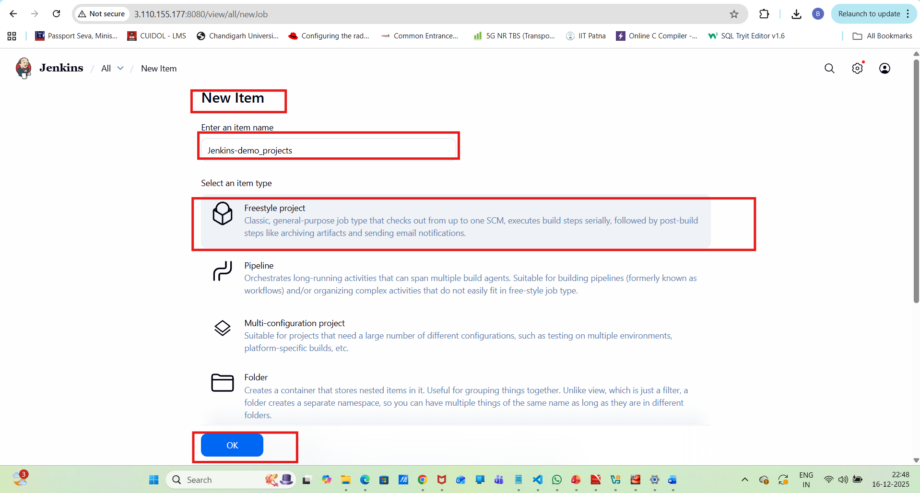
Configure the project:
Under Build Steps, select Execute Shell
Add a command:
#!/bin/bash
set -e
echo "Starting build..."
echo "Checking system info"
uname -a
echo "Simulating build task"
sleep 2
echo "Build completed successfully"………………………………..
Click Save.
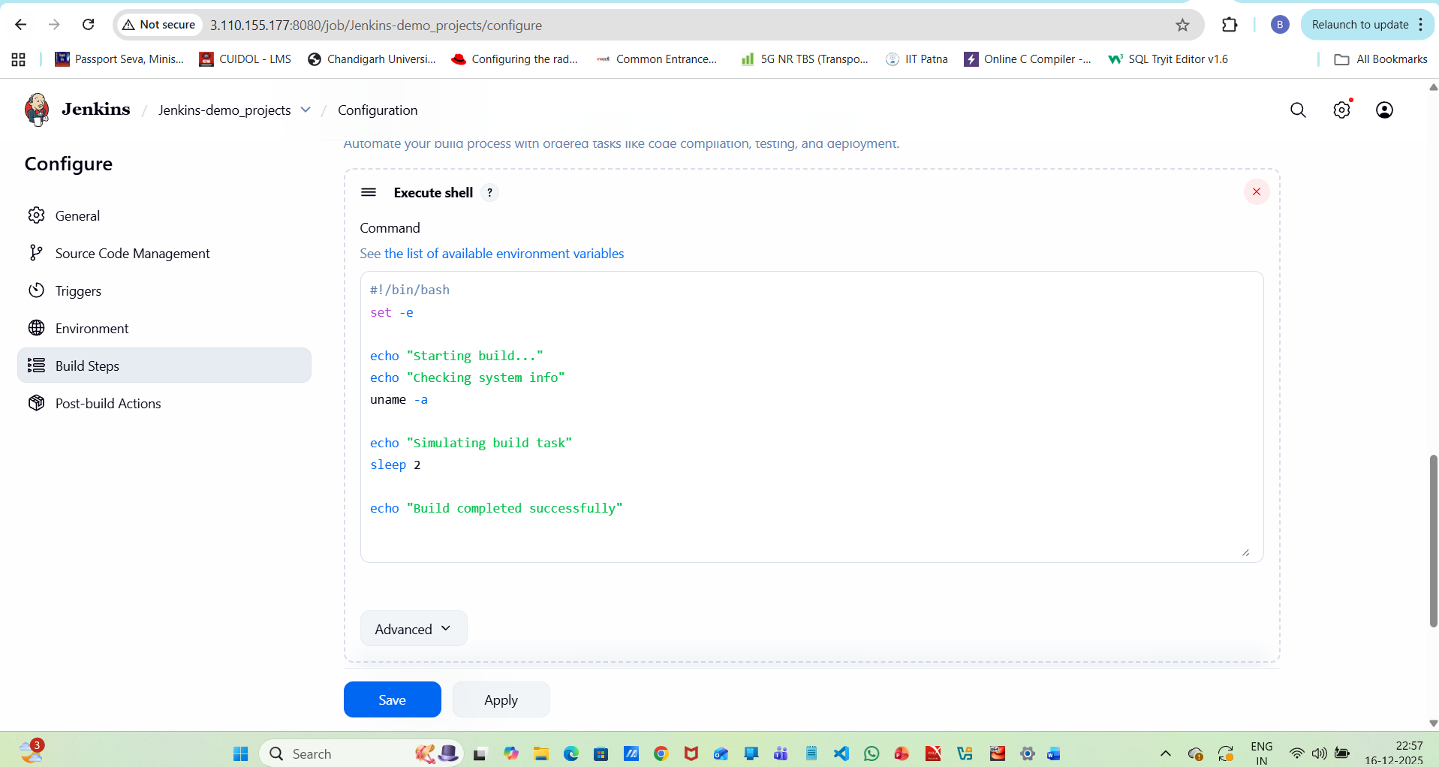
Click Build Now.
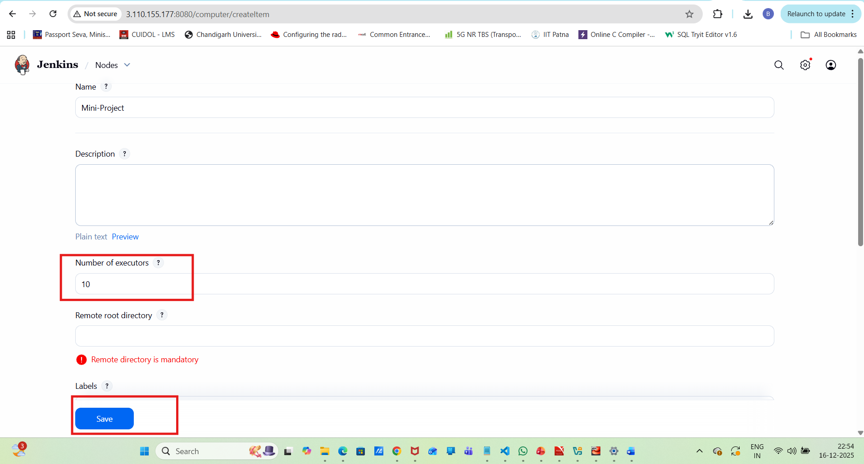
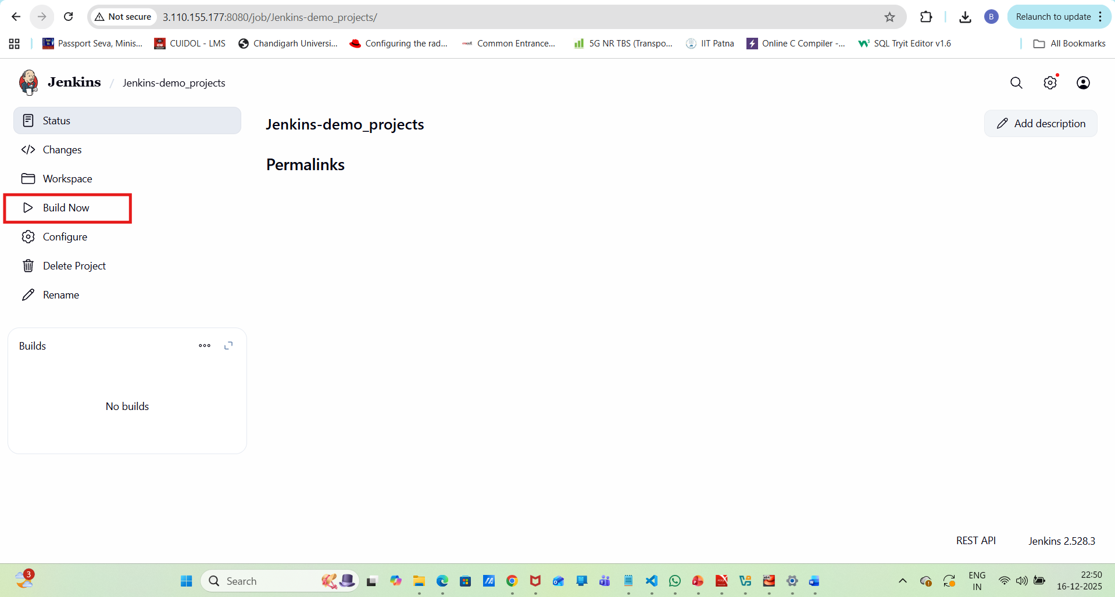
Verify build success under Console Output.
Step 9: Create Jenkins Users
Go to Manage Jenkins → Manage Users.
Click Create User.
Enter:
Username
Password
Full Name
Email
Click Create User.
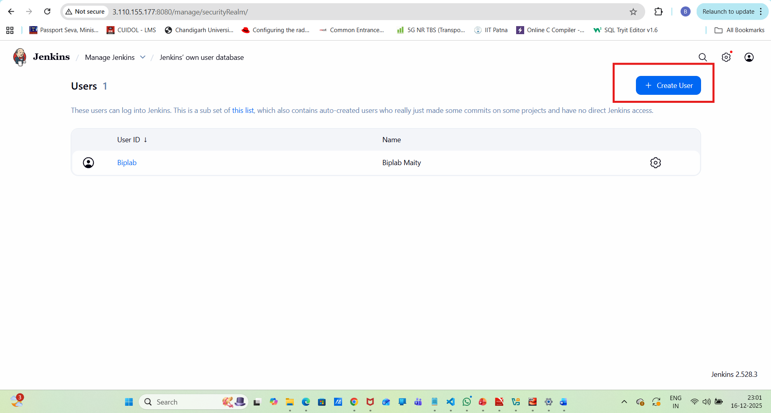

Step 10: Configure User Permissions
Go to Manage Jenkins → Security.
Under Authorization, select:- Matrix-based security
Assign permissions such as:
Read
Build
Job Configure
Administer (for admin users)
Save the configuration.
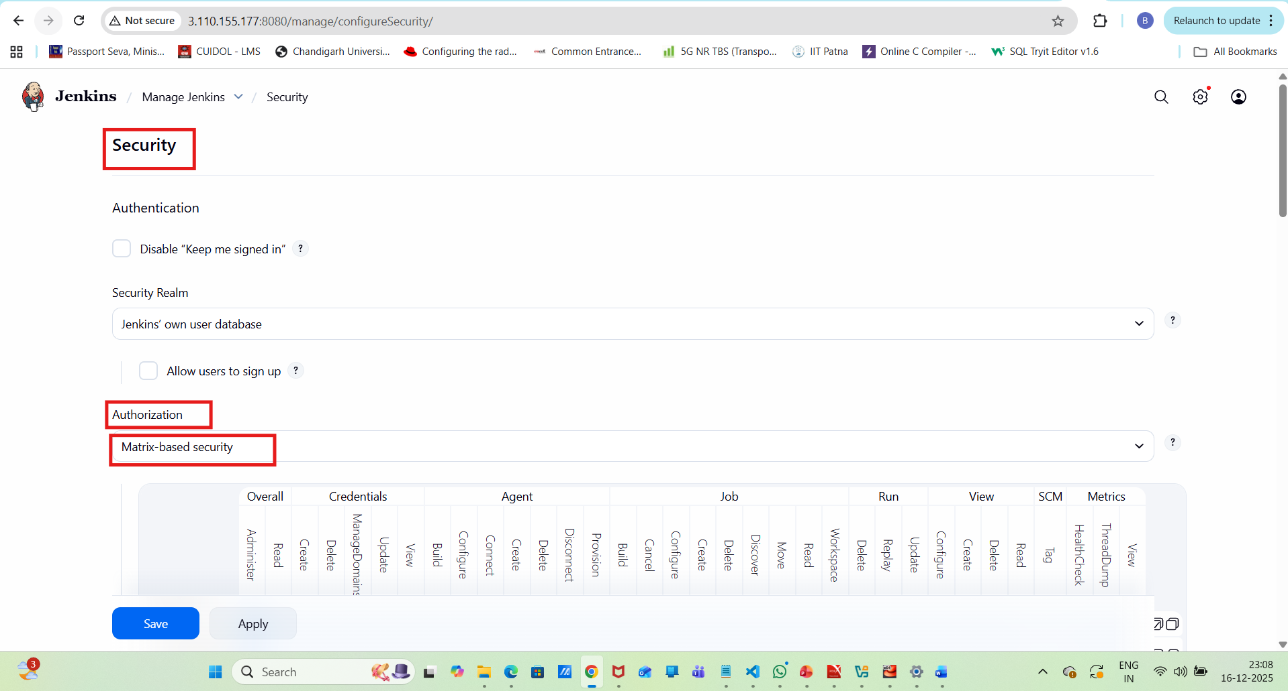
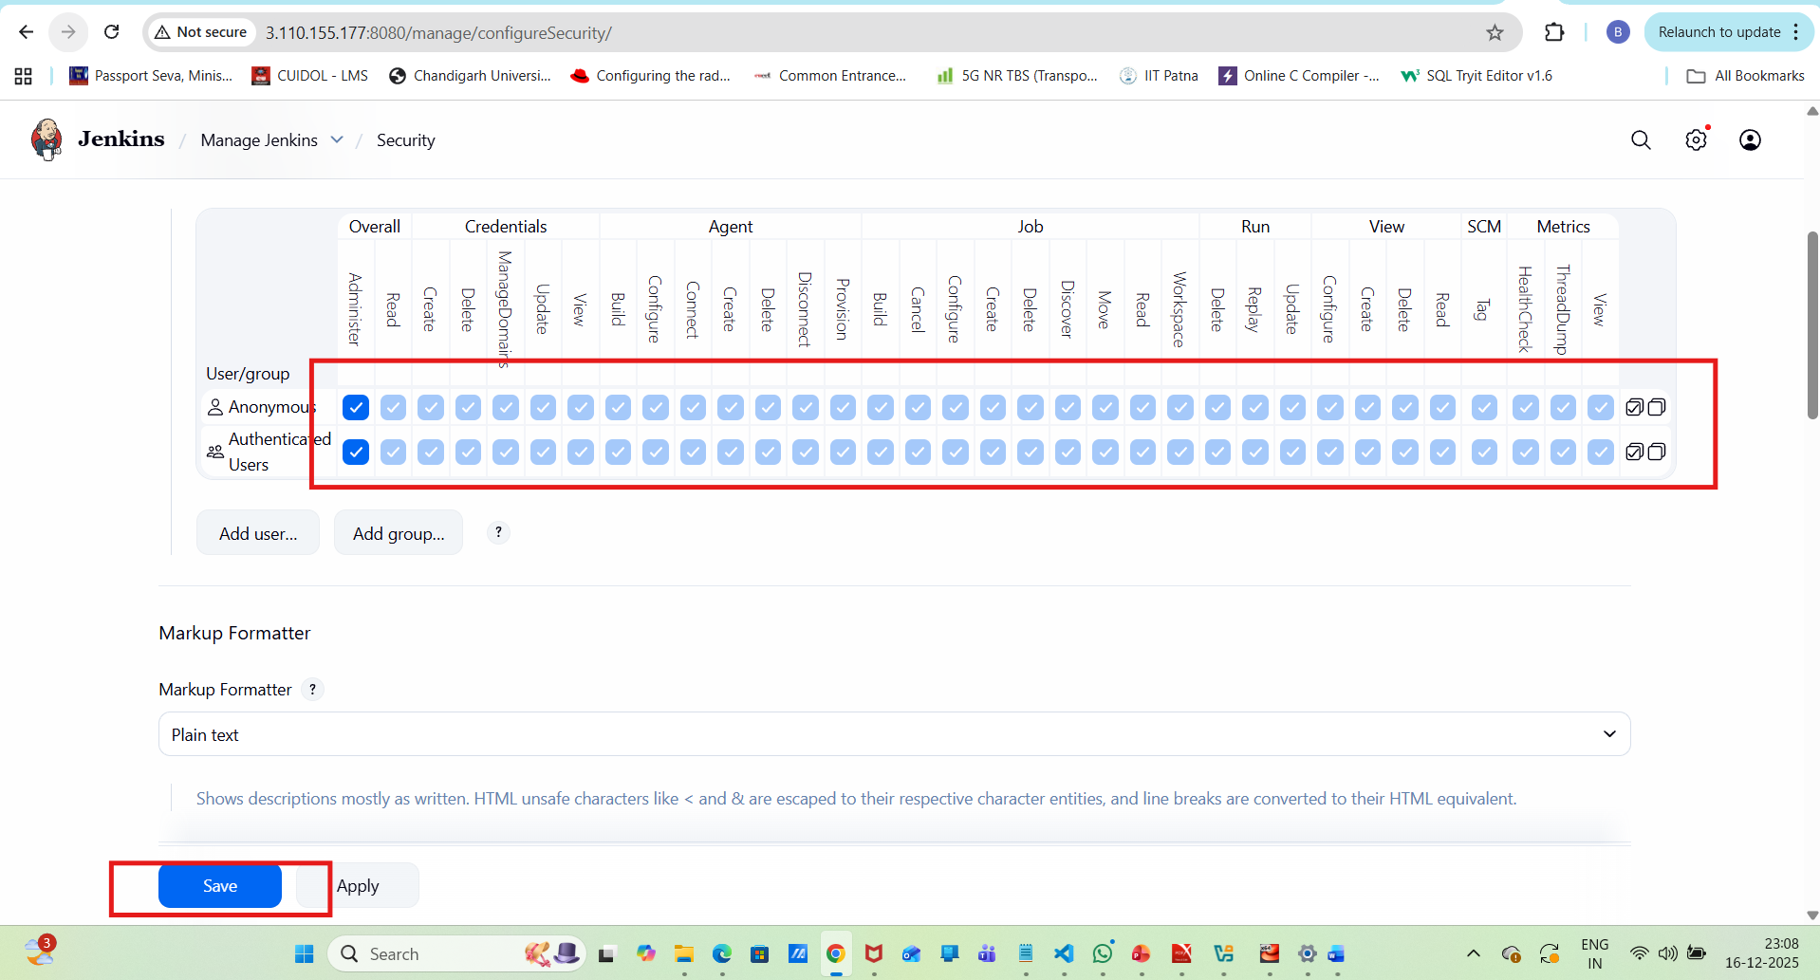
Step 11: Validate User Access
Log out from Jenkins.
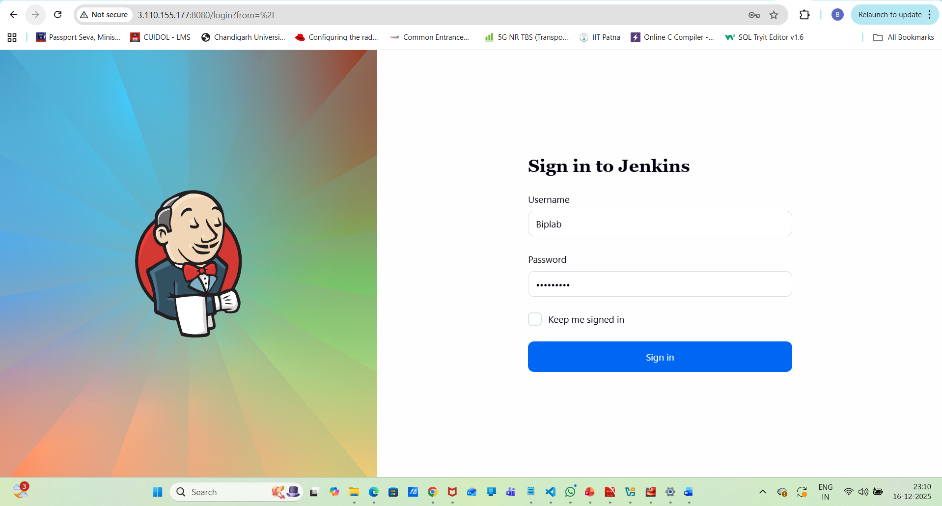
Log in using the newly created user.
Verify:
